SECRET – MANAGER – TASKS

Title
Secure Storage and Retrieval of Database Credentials Using AWS Secrets Manager (CLI and Console)
Objective
To securely create, store, and retrieve database credentials using AWS Secrets Manager by leveraging the AWS CLI, and to verify the stored secrets through the AWS Management Console, ensuring credentials are encrypted, centrally managed, and not hardcoded in applications.
Prerequisites
- An active AWS account
- IAM user or role with permissions for secretsmanager:CreateSecret and secretsmanager:GetSecretValue
- AWS CLI installed and configured with valid credentials
- Access to the AWS Management Console

Conclusion
The database secret was successfully created using the AWS CLI and securely stored in AWS Secrets Manager with KMS-backed encryption. The secret values were retrieved programmatically via CLI and verified through the AWS Management Console, confirming consistency and secure handling. This approach improves security by eliminating hardcoded credentials, enables centralized secret management, and aligns with AWS best practices for protecting sensitive information.

Step 1: Opened Amazon RDS and Started Database Creation
- Navigated to AWS Console → Amazon RDS → Databases.
- Clicked Create database.
- Selected Standard create (Full configuration).
Step 2: Selected Database Engine
- Chose MariaDB as the database engine.
- Selected the MariaDB engine version (e.g., MariaDB 11.x as shown).
- Proceeded with default engine settings.
Step 3: Configured Database Settings
- Provided a DB instance identifier (example: database-1).
- Set Master username as:
- admin
Step 4: Enabled Credentials Managed by AWS Secrets Manager
- Selected Managed in AWS Secrets Manager (most secure).
- This option allows AWS to:
  - Automatically store database credentials
  - Securely encrypt credentials using KMS
- Selected the default encryption key:
- aws/secretsmanager (default)
Step 5: Completed Database Creation
- Continued with remaining default configurations (instance class, storage, networking).
- Created the MariaDB RDS instance.
- Database was successfully launched.
Step 6: Verified Database Connectivity and Security
- Opened the created RDS instance.
- Navigated to the Connectivity & security tab.
- Verified:
  - VPC and subnet group
  - Security groups
  - Database is not publicly accessible
  - Endpoint and port are assigned
Step 7: Opened AWS Secrets Manager
- Navigated to AWS Secrets Manager → Secrets.
- Located the secret automatically created by Amazon RDS.
- Secret name followed the pattern:
- rds!db-<unique-id>
Step 8: Viewed Stored Database Credentials
- Opened the RDS-created secret.
- Viewed Secret value.
- Verified stored credentials:
  - Username: admin
  - Password: (auto-generated secure password)
- Confirmed that credentials are securely stored and retrievable.
Final Result
- MariaDB RDS database successfully created
- Database credentials securely stored in AWS Secrets Manager
- No hardcoded passwords used
- Credentials protected using AWS-managed KMS encryption
- Secure and production-ready database setup completed

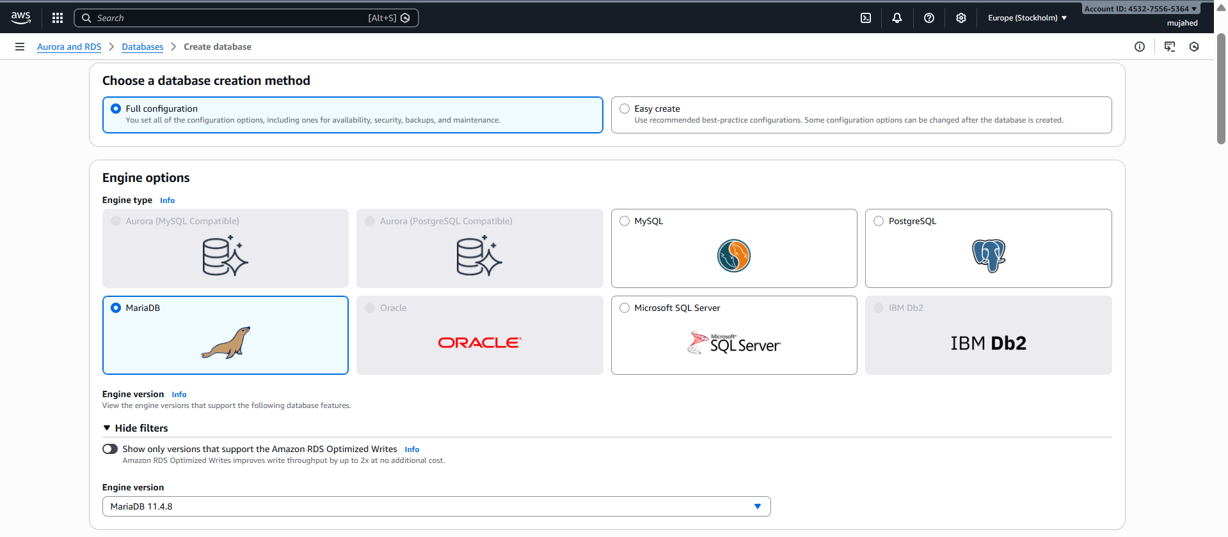

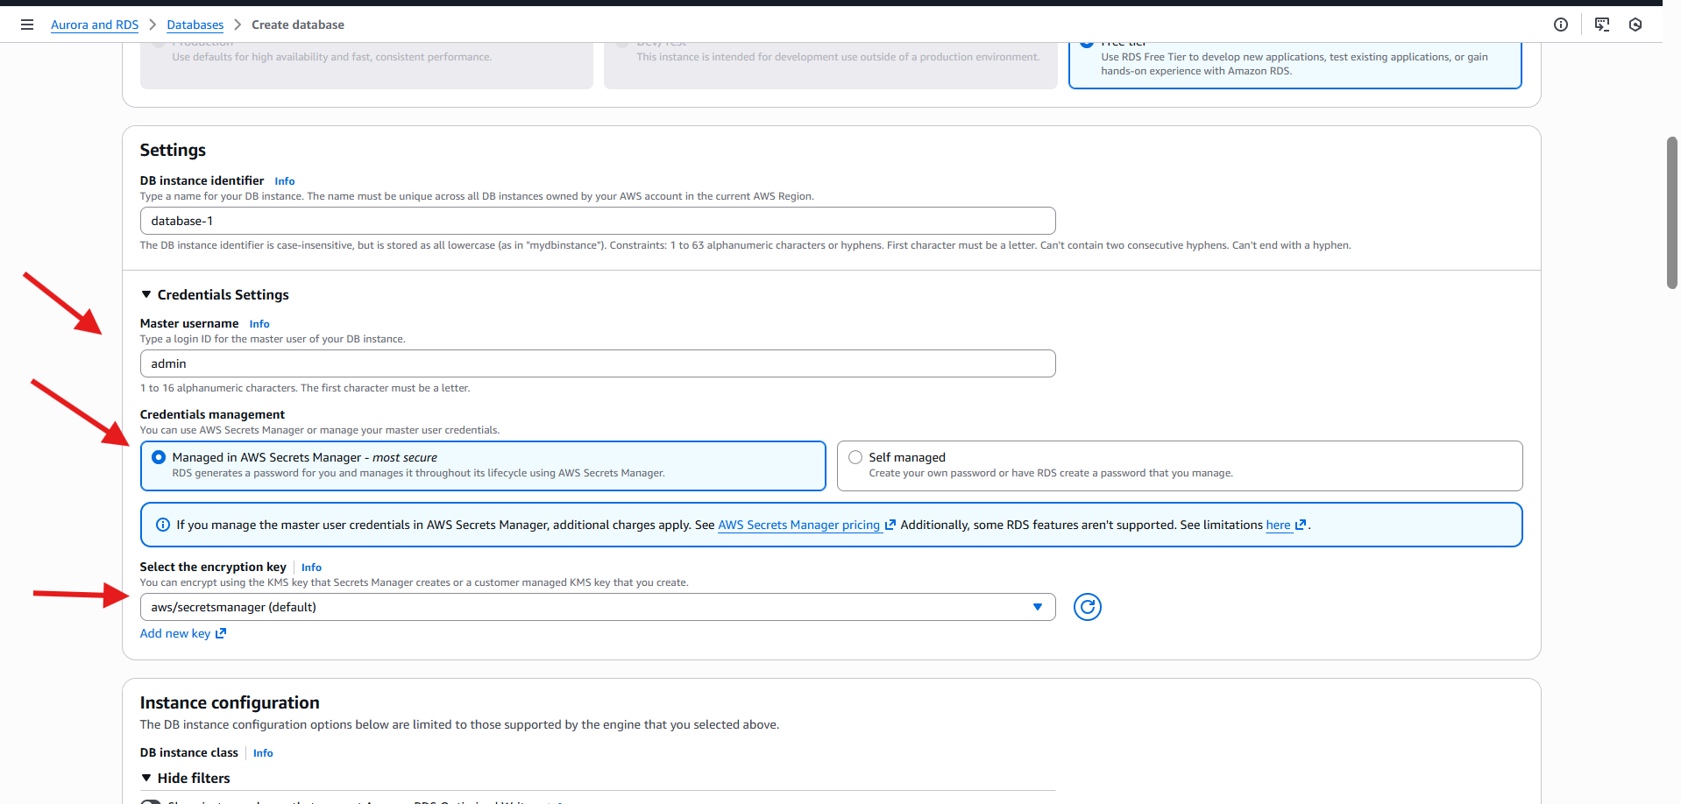

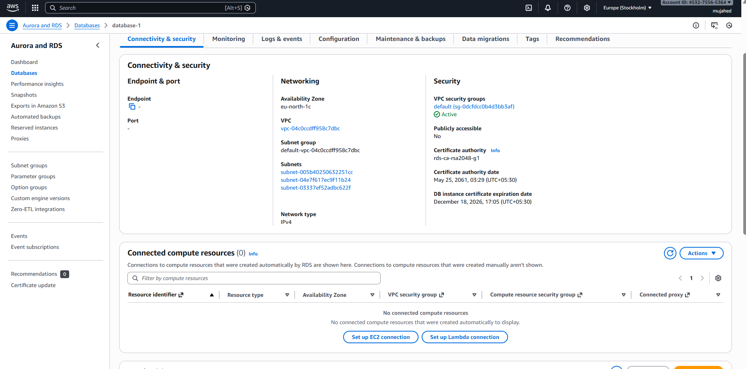

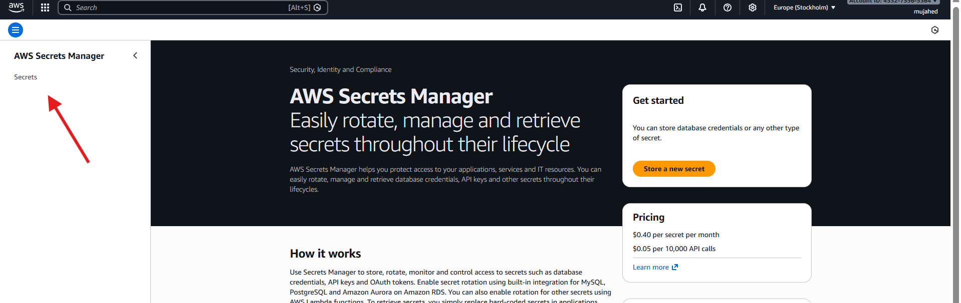

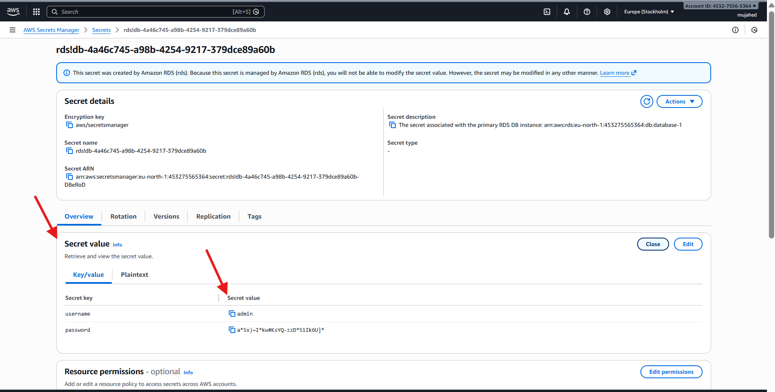

Steps Performed (AWS Secrets Manager – Store a New Secret)
Step 1: Opened AWS Secrets Manager
- Navigated to AWS Console → AWS Secrets Manager.
- Clicked Store a new secret.
Step 2: Chose Secret Type
- Selected Other type of secret.
- Chose Key/value pairs.
- Entered secret values:
  - username → admin
  - password → StrongPassword123
- Selected encryption key:
  - aws/secretsmanager (default KMS key).
- Clicked Next.
Step 3: Configured Secret Name and Description
- Entered Secret name:
- my/secret
- (Optional) Added a description.
- Did not add tags or resource permissions.
- Clicked Next.
Step 4: Configured Rotation (Optional)
- Reached Configure automatic rotation page.
- Left automatic rotation disabled.
- No Lambda rotation function selected.
- Clicked Next.
Step 5: Reviewed and Stored the Secret
- Reviewed all secret details.
- Clicked Store secret.
- AWS displayed a success message confirming the secret was stored.
Step 6: Verified the Secret in Secrets List
- Returned to Secrets Manager → Secrets.
- Verified the new secret my/secret appears in the list.
Step 7: Viewed Secret Details and Values
- Opened the secret my/secret.
- Verified:
  - Encryption key: aws/secretsmanager
  - Secret name and ARN
- Viewed Secret value:
  - Username: admin
  - Password: StrongPassword123
Final Result
- A custom secret was successfully created in AWS Secrets Manager
- Secret values were stored securely using AWS KMS encryption
- Credentials can now be retrieved securely by applications without hardcoding

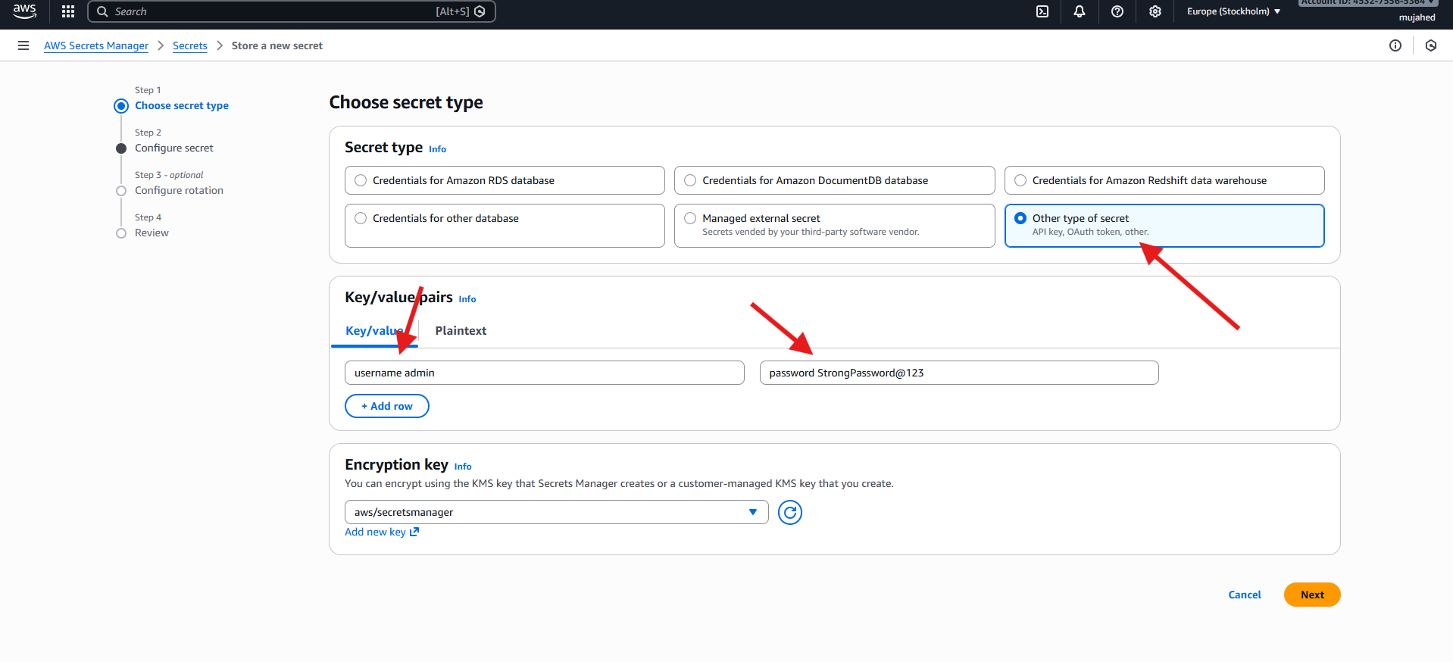

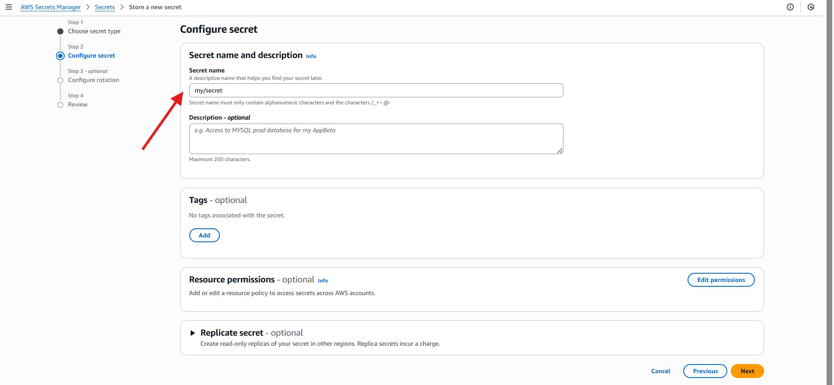

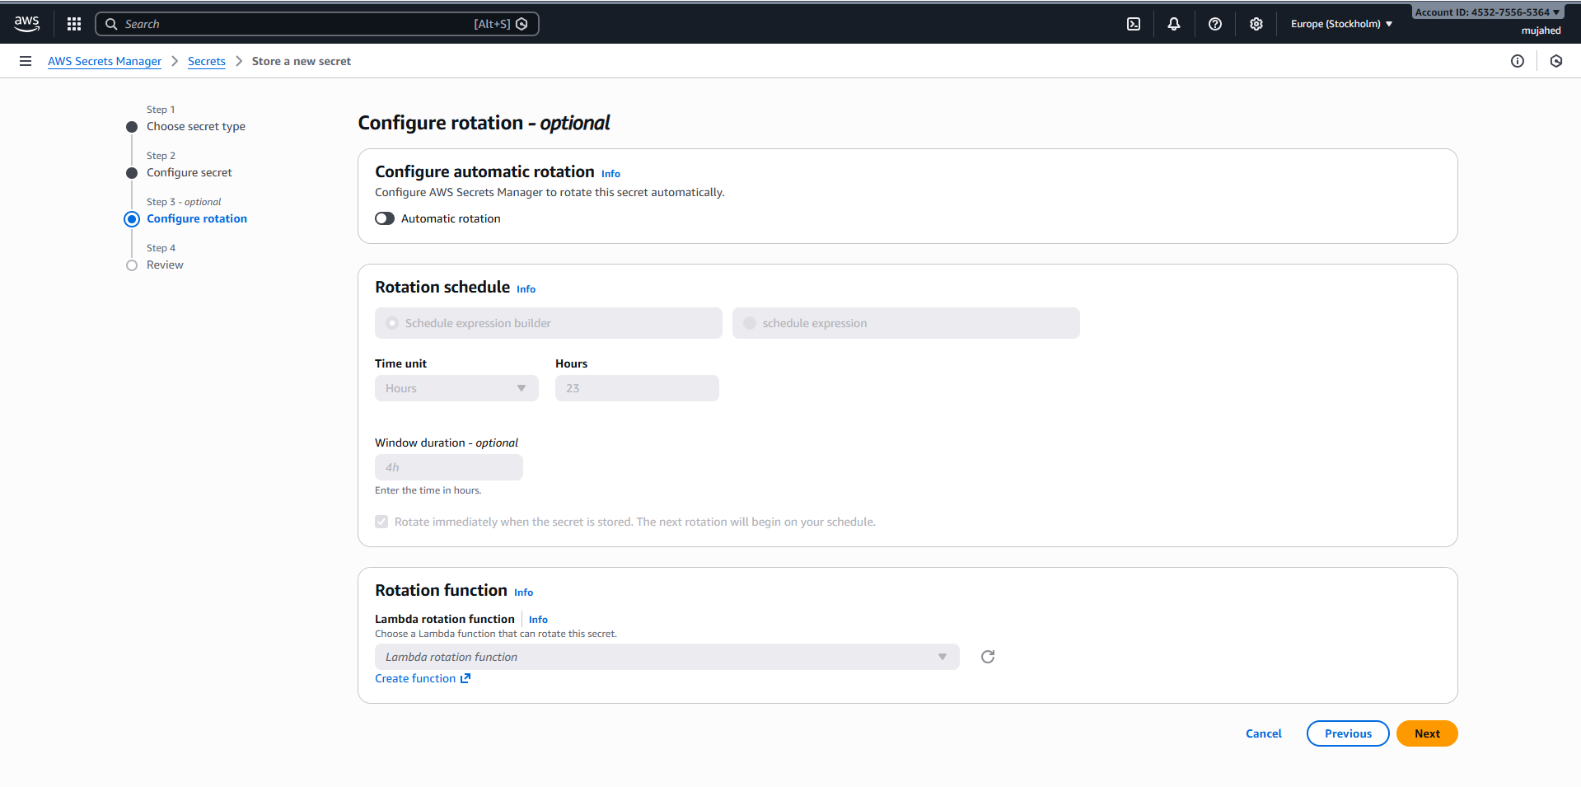

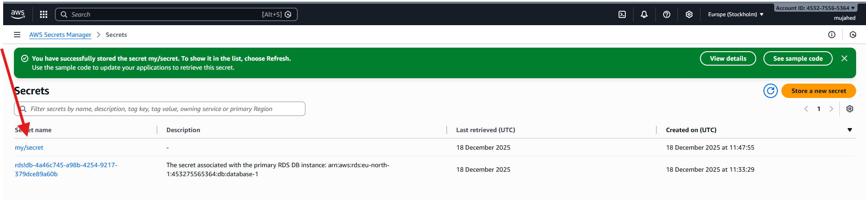

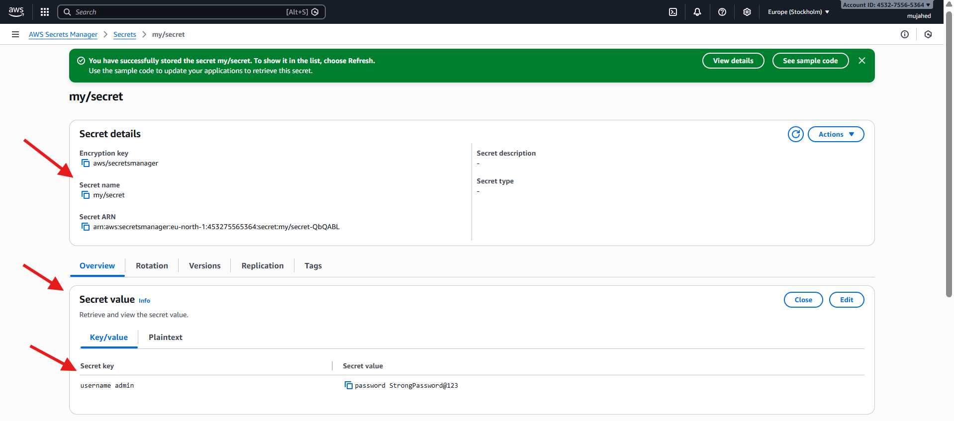

Step 1: Created a Secret Using AWS CLI
- opened a terminal (Git Bash on Windows).
- Used AWS CLI to create a new secret in AWS Secrets Manager.
- Provided:
  - Secret name
  - Description
  - Username and password in JSON format
Command executed:
aws secretsmanager create-secret \
--name my-db-secret \
--description "My database credentials" \
--secret-string '{"username":"admin","password":"Pass@123"}'
Step 2: Verified Secret Creation Output
- AWS CLI returned a successful response containing:
  - Secret ARN
  - Secret name (my-db-secret)
  - Version ID
- This confirmed that the secret was successfully stored in AWS Secrets Manager.
Step 3: Retrieved the Secret Value Using AWS CLI
- fetched the stored secret using the secret name.
Command executed:
aws secretsmanager get-secret-value \
--secret-id my-db-secret
Step 4: Verified Retrieved Secret Details
- AWS CLI returned:
  - Secret ARN
  - Secret name
  - Version ID
  - SecretString containing:
  - {
  - "username": "admin",
  - "password": "Pass@123"
  - }
- Confirmed the secret version stage as AWSCURRENT.
Step 5: Opened AWS Secrets Manager Console
- Navigated to AWS Console → AWS Secrets Manager → Secrets.
- Verified that my-db-secret appears in the secrets list.
- Confirmed the description:
- My database credentials
Step 6: Viewed Secret Details in AWS Console
- Opened the secret my-db-secret.
- Verified:
  - Encryption key: aws/secretsmanager
  - Secret name and ARN
Step 7: Viewed Stored Secret Values
- Opened the Secret value section.
- Viewed key/value pairs:
  - username → admin
  - password → Pass@123
- Confirmed that the values stored via CLI match the console view.
Final Result
- Secret was successfully created using AWS CLI
- Secret values were securely stored and encrypted using AWS KMS
- Secret retrieval was validated using both:
  - AWS CLI
  - AWS Management Console
- Credentials are now securely managed without hardcoding

